Infant Maths Evening
Tonight you’ll hear vocabulary you may be unfamiliar with. Below is a list of words and the definition opposite. They are not next to each other! After the meeting see if you can match up the definition with the meaning.
Stem Sentence | Children writing down their answers and then sharing them at the same time.
Subitise | Quickly and accurately recalling number facts.
Stash and Flash | Instantly recognising a small number of objects without counting.
Fluency | A structured sentence that helps children communicate their ideas.

Thank you for attending this evening. If you have any questions or comments, please could you write these on a post it and put them on one of the feedback posters in the hall.

The Mastering Number at Home project is still in its infancy and NCETM are keen to have feedback from parents. Please complete this form after finishing the 5 week project.
Scan the QR code below to access the form.
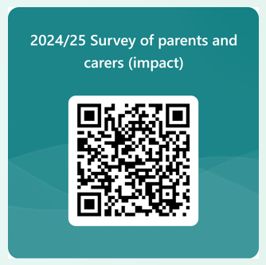

What is Mastering Number and why is your involvement so important?
Research proves that high quality teaching in school is key to raising attainment. However, a parent/carer’s role is also really important!
The help that parents give their children at home has a very significant impact on their learning.
Development Matters (2023)

The Mastering Number Programme is a new national programme based on research into what is important in early maths education.
The numbers children use in this programme may be smaller than they can do at home but we are purposefully focusing on smaller numbers so that the children can develop a deep understanding of numbers to develop that good number sense.
Children will be learning gradually to count out larger sets of objects and join in with the counting numbers. To have a really good foundation to build on, the smaller numbers are so important.

The Mastering Number Programme will help children develop good number sense from Reception to Year 2. Some of the things they are learning include:
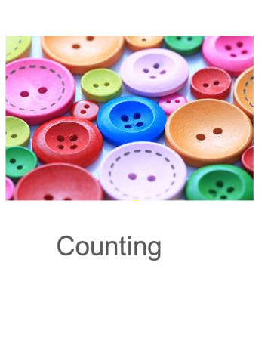
Reception Reception, Year 1, Year 2 Reception, Year 1, Year 2
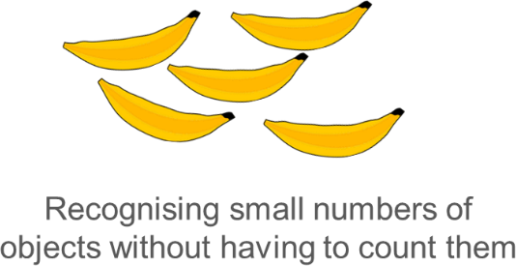
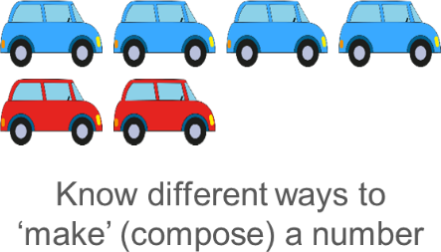

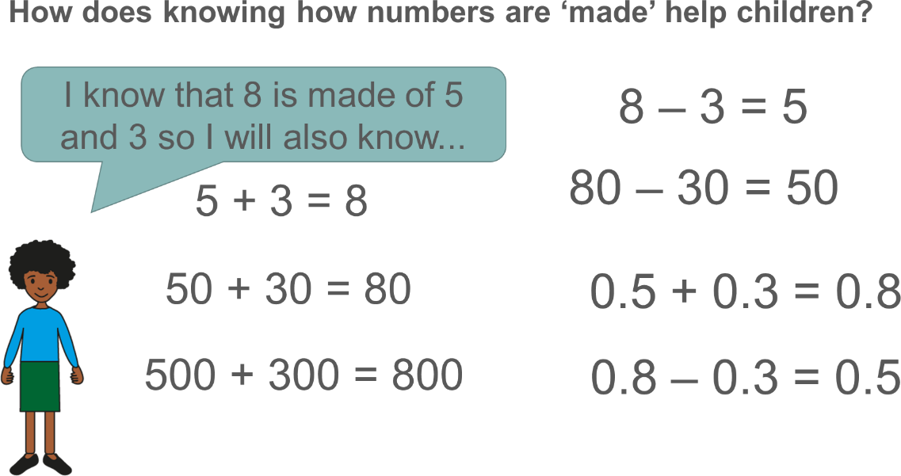
Children who develop good number skills early on are much more confident and capable in maths later on.

