Mastering Number at Home
Year 1 – Week 2
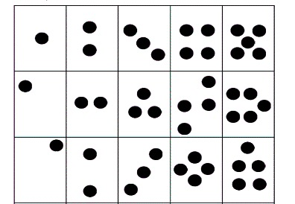  Find pairs to 6 (with dots)  (Monday, Wednesday and Friday)  How to play  - Cut out the cards on the worksheet ‘Find pairs to 6 (with dots)’ and place them face-up on a flat surface.  - Pick up 1 card. Can your child find its partner, so the 2 cards together make 6? (e.g. 5 and 1, 4 and 2, etc.)  - Repeat, so your child can practise finding all the ways to make 6.  - [Try this game without counting the dots. Encourage your child to remember the ways to make 6.]  - On Friday, you may wish to time your child to see how quickly they can find all the ways to make 6. | Egg box 6 (with missing numbers)  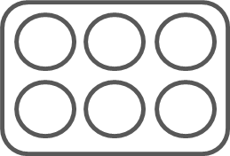  (Tuesday and Thursday)  How to play  - For this game you will need an egg box and 6 small objects, such as blocks or acorns.  - Put some of the objects into the spaces in the egg box and hide the others.  - Close the lid, then open it briefly to show your child what is inside. Ask, “How many more to make 6?”  - Encourage your child to use the stem sentence to say how many more are needed to make 6, e.g. “4 needs 2 to make 6.” [See the worksheet ‘Stem sentences’ for guidance.]  - Take it in turns to put objects into the egg box. Remember to vary the spaces and number used each time, and to use the stem sentence to say how many more to make 6.
Other things to try at home
A pretend party
Ask your child to imagine they have invited 6 people to a party at their house (or you may wish to set up a pretend party for 6 soft toys). Show them 3 plates (lay them on a table if possible). Say, “We have 3 plates. How many more will we need for 6 people?”

Then, do the same with spoons, forks, cups, etc., changing the number of objects you start with each time. Can your child tell you how many more are needed without counting?
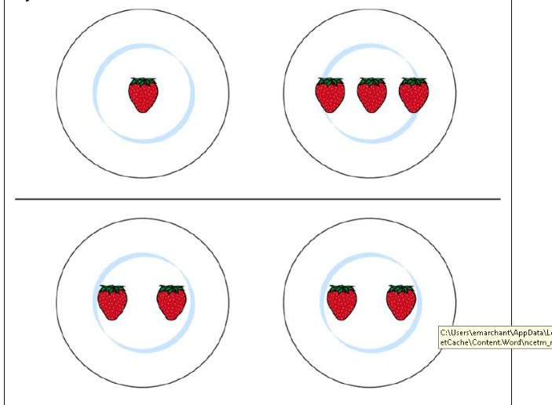

How many more plates do we need to make 6?

