Mastering Number at Home
Year 2 – Week 2
Ways to make 10    (Monday, Wednesday and Friday)  10 is made of 9 and 1.  9 and 1 make 10.  How to play  - For this game, you will need the 10-frame from Week 1 and 10 two-colour counters.  - Fill each space on the 10-frame with a counter, ensuring that they all show the same colour.  - Ask your child to turn 1 counter over and look at the numbers they have made.  - Ask them to use the stem sentence to say the numbers they can see, for example, “10 is made of 9 and 1. 9 and 1 make 10”. [See the ‘Stem sentences’ worksheet for guidance.]  - Turn a second counter over. Use the stem sentence to say the numbers you can see.  - Repeat the activity until all the counters have been turned over. | How many more to make 10?  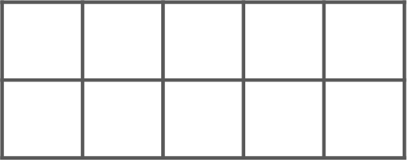  6 needs 4 to make 10.  (Tuesday and Thursday)  How to play  - For this game, you will need the 10-frame from Week 1 and 10 two-colour counters.  - Place some counters on the 10-frame, ensuring they all show the same colour.  - Ask your child to fill all the remaining spaces on the 10-frame with counters facing the other way up (so that they show a different colour).  - Without counting, can your child say how many more are needed to make 10? Encourage them to use the stem sentence, for example, “6 needs 4 to make 10”. [See the ‘Stem sentences’ worksheet for guidance.]  - Repeat the activity, taking it in turns to place the first counters on the 10-frame. How many ways can you find to make 10?
Other things to try at home

How many are hiding?
Find 10 of the same kind of object in your home, for example buttons, coins or dried beans.
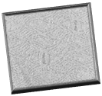

Take it in turns to place the 10 objects on a flat surface and use a cloth to hide some of them. Look at the objects you can see. If there are 10 altogether, can your child say how many are under the cloth?

How many are hiding?

